**GROUP 7**

**PR. EMRE YETGIN – DIRECTOR, CENTER FOR BUSINESS ANALYTICS**

**PMBA-8355-OLB VISUAL ANALYTICS**

**GROUP PROJECT STEP 3: BASIC VISUALISATION**

1. PART 1 – CONNECT TO YOUR DATASET IN TABLEAU

→ by Madhavi and Jeremy

First, we started this assignment by successfully connecting the cleaned version of our dataset presented in the precedent group submission. The file is an excel file so we didn’t encounter any problems. Please find the screenshot of the Data Source Screen.

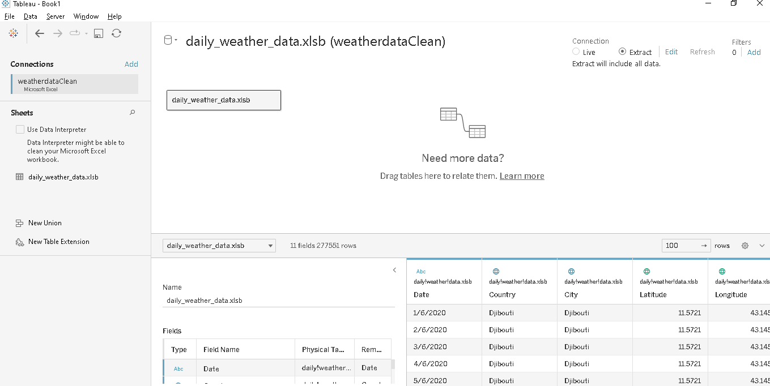

To complete the connection we opted for the Extract Connection for the following reasons:

* It takes very less time to perform and execute visualization than connecting to Live data.
* We are not performing visualization on any transactional data that needs to be updated day in and day out.
* Instead, we are using analytical data such that we can perform some calculations on temperature and wind variables from our weather dataset.

This dataset contains the daily weather data recorded in the capital location (based on latitude,

and longitude values) of 194 countries in the world. The dataset presents information about the date,

country, city, latitude, and longitude in addition to the quantitative columns to be analyzed.

The weather dataset now is connected and saved as a Data Source in tableau and ready to perform analysis and visualizations. It contains the following 11 columns with default data types as defined by Tableau:

* 3 Dimensions:

Date (ABC)

Country (Geographic discrete dimension)

City (Geographic discrete dimension)

* 8 Measures:

Average Temperature (Number (decimal))

Temperature Minimum (Number (decimal))

Temperature Max (Number (decimal))

Wind direction (Number (whole))

Wind Speed (Number (decimal))

Pressure (Number (decimal))

Latitude (Geographic continuous variable)

Longitude (Geographic continuous variable)

* Corrected Date data type:
* Once the dataset is loaded, verified all these 11-column data types defined by tableau are correct or not.
* As explained in the previous submission, we were encountering problems formatting the date so the format of Date (ABC) was not correct and we were able to correct this issue on Tableau to its accurate data type: Date.

1. PART 2 & 3: CREATE 10 VISUALIZATIONs AND EXPLAIN THE STORY BEHIND

→ Visualization 1 to 6: by [Jeremy Peterson Dutoya](mailto:petersonduj@rider.edu)

→ Visualization 7 to 10: [Madhavi Maitri](mailto:maitrim@rider.edu)

Visualization 1: Evolution of the Temperature Minimum over the last 4 years: 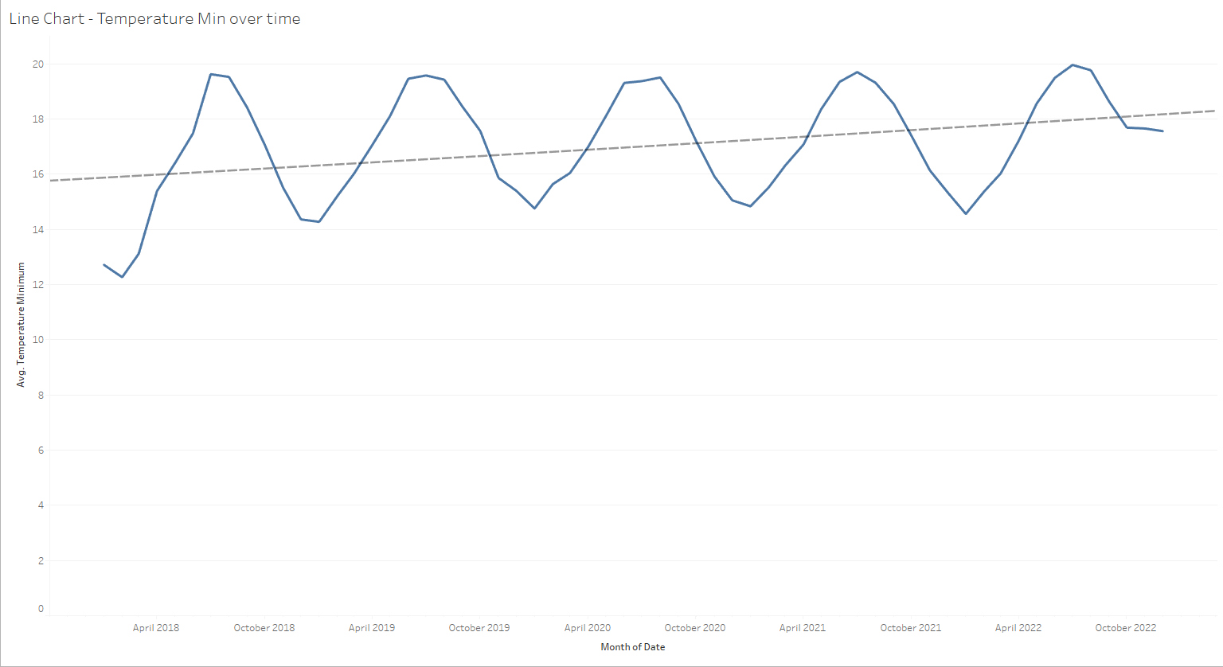

In this visualization we have, put forward the evolution of minimum temperatures over time in order to highlight whether or not we suffer from a climate change that would be seen in the figures we have in our dataset. If the start graph does not suggest a positive evolution, the trendline we added to the chart gives more information because it clearly shows a trend to increase, light but subtle, of the minimum temperatures. In summary, we can see that the lowest temperatures are increasing and warming little by little.

Visualization 2: Temperature Max in the world in the Past 4 Years:

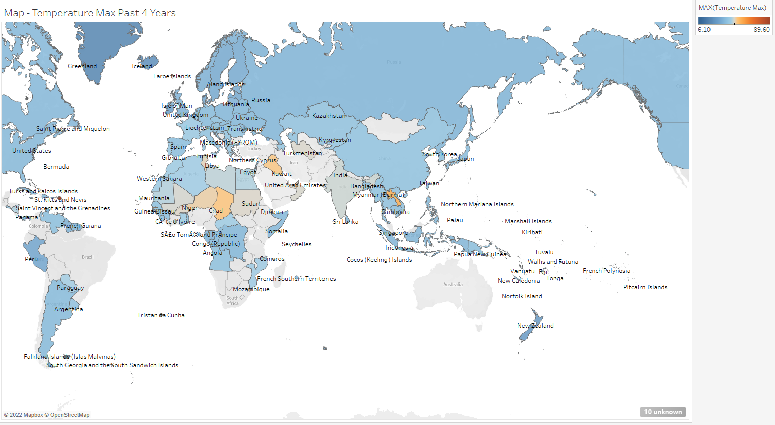

What better way to visualize global temperature trends than with a map. In this map, we can see the warmest places on average in the world over the last 4 years. This gives a global trend in the distribution of temperatures. We can start to have ideas about the line on which are the countries with the warmest temperatures for example and the global temperature of the world. This visualization is particularly useful to compare with the following two that help draw robust conclusions:

Visualization 3: Temperature Max in the World in 2022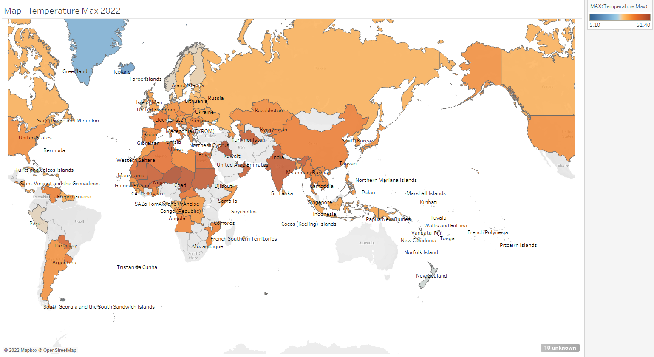

By comparing this graph with the previous one we can immediately see that the global temperature of the world has increased everywhere. The previous graph showing an average over the previous 4 years had a general blue color trend reflecting softer temperatures, the more pronounced orange color on this visualization shows that the trend has changed for much warmer temperatures.

Visualization 4: Line Chart - Max Temperature by Year

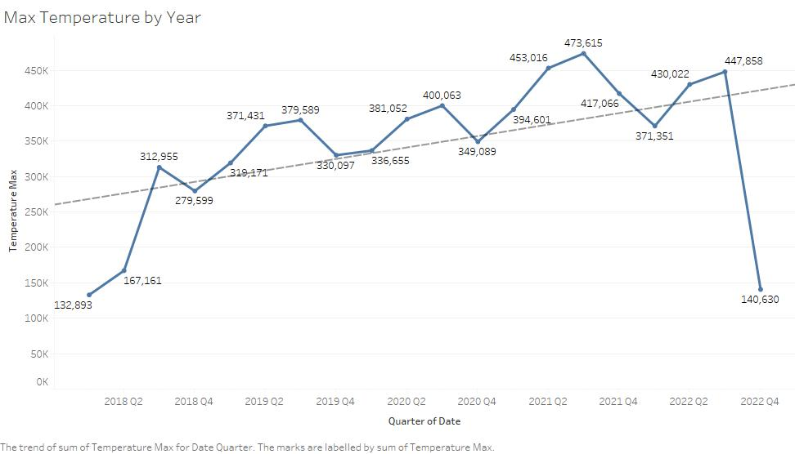

Our conclusion on the precedent visualization goes hand in hand with that which also shows an increase in temperature and this even if the end of the year 2022 is missing. The trend line is unequivocal: we are witnessing an increase in temperature and our visualizations come together to insist on this idea.

Visualization 5: Comparing the Pressure with the Temperature in USA

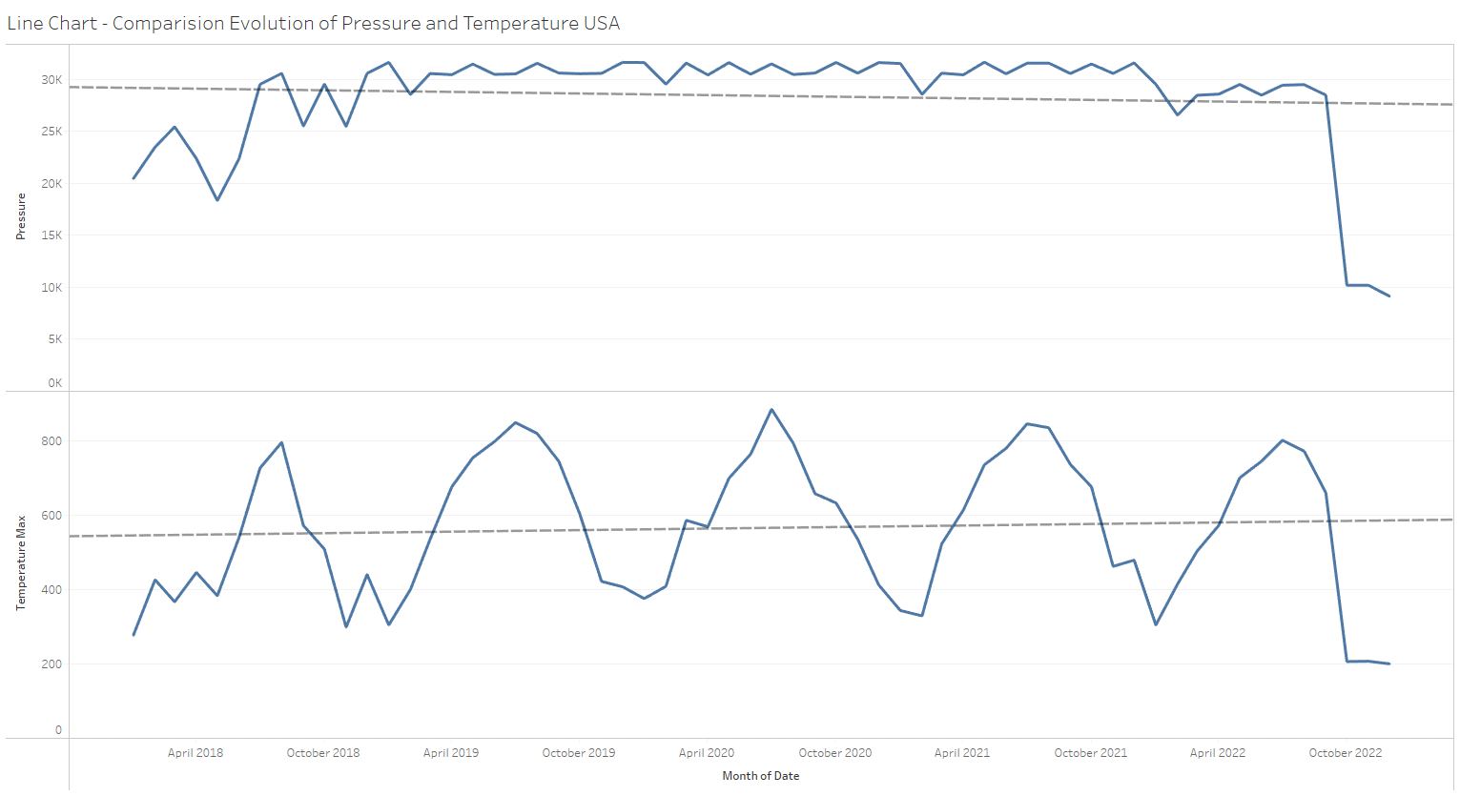

In this chart, we have tried to compare the evolution of pressure in the US with that of temperature. At first sight, these two variables are not correlated at all, we see cyclical changes in temperature over the seasons but we cannot say the same about pressure. Finally, after analyzing the trend line, we can see that the pressure has been decreasing subtly for the last 4 years while the temperature is increasing subtly.

Visualization 6: Seasonality of Air Pressure

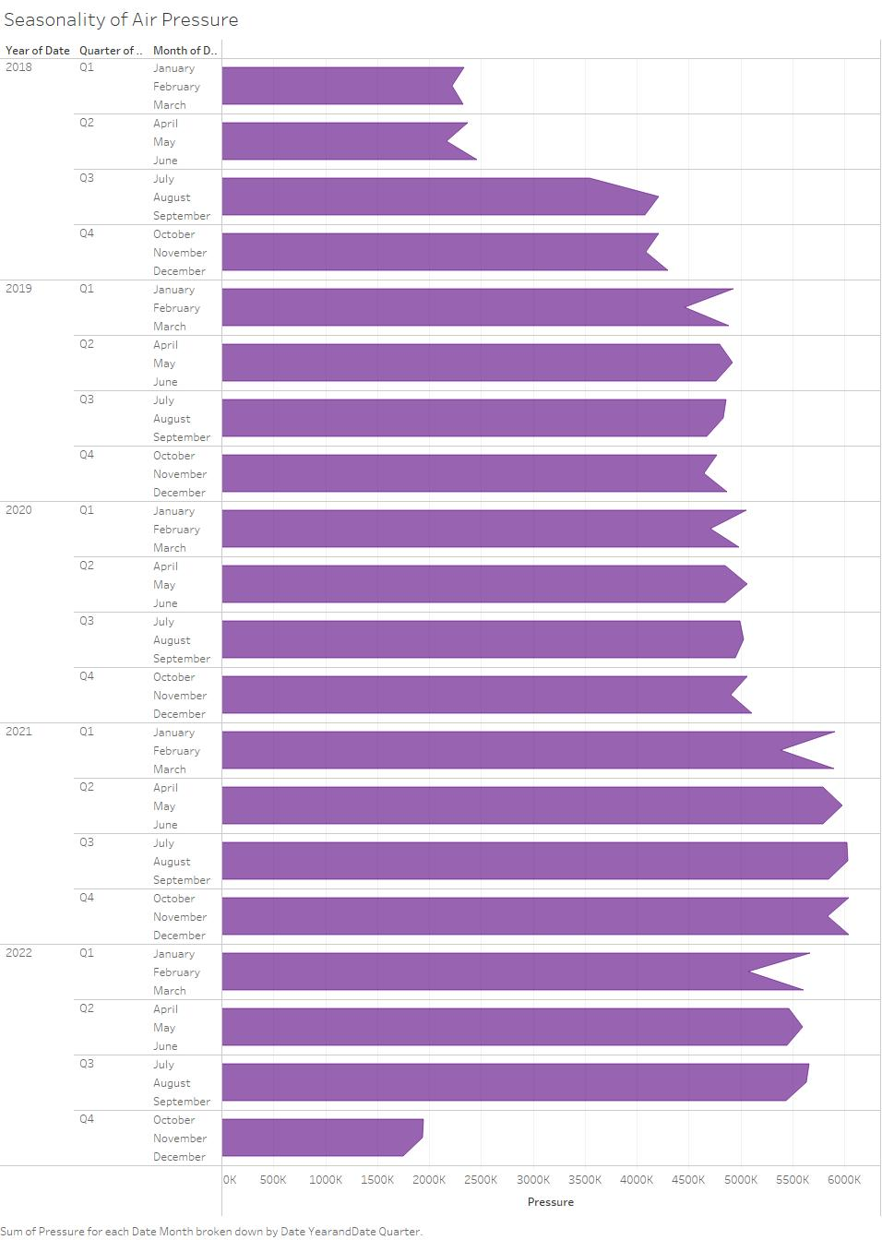

With this chart, it is a completely different vision that we have of the evolution of global atmospheric pressure. We can well see that this has led to a steady increase in atmospheric pressure. The last Q4 of 2022 is still in progress we can not interpret this last quarter.

Visualization 7:

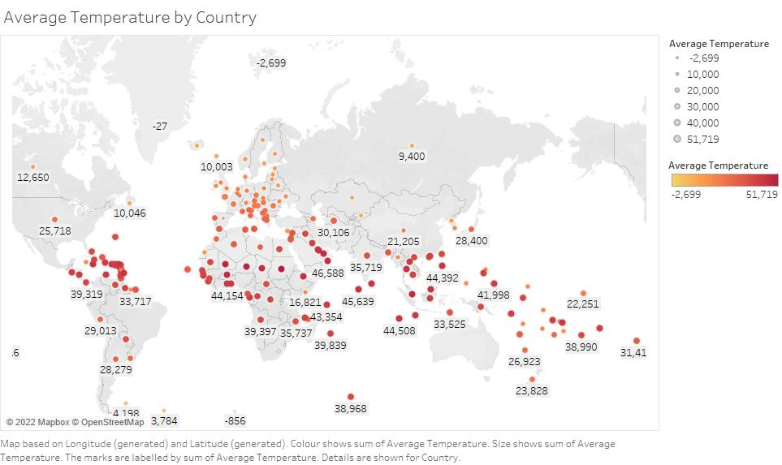

The above geographical map makes it abundantly evident that there is little variation in global average temperature across all nations. Each dot's color and size displays the range of average temperature that is indicated.

Visualization 8:

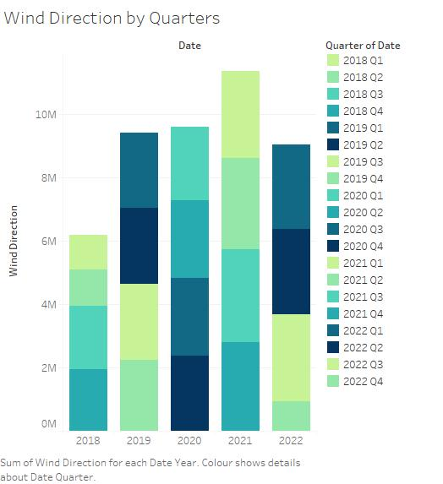

The stacked bar graph above shows that from 2018 to 2021, the wind direction will be increasing. Additionally, every season's wind direction varies greatly from year to year. In 2021, the amount of wind direction is equal for each quarter.

Visualization 9:



Over the years, the maximum temperature has essentially stayed steady and been kept at an average level. However, it was at least 130 degrees Fahrenheit when it began and concluded.

Visualization 10:

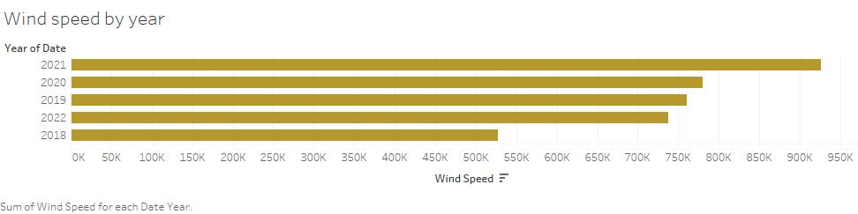

The Wind Speed over the previous 4 years is summarized in the Horizontal Bar Chart view. As opposed to being at its lowest in 2018, the wind speed was at its maximum in 2021. The control of the environment, especially during the covid era, is the reason for the distinction between these.